Meeting Room Booking Form |  |  |  |  |  |  |  |  |  |  |  |  |  | 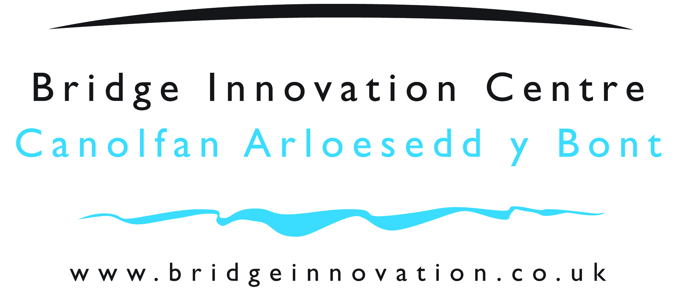
Please E-mail completed booking forms to : pstp@pembrokeshire.gov.uk |  |  |  |  |  |  |  |  |  |  |  |  | Today’s Date: July 29, 2026
YOUR CONTACT DETAILS  Name Of Your Organisation:  Your Name:  Invoice Address:  Your Order Number:  Your Contact number:  Your Contact e-mail: |  |  |  |  |  |  |  |  |  |  |  |  | Our Contact Details:  Pembrokeshire Science and Technology Park  Pembroke Dock  Pembrokeshire  SA72 6UN  Tel: 01646 689200  Fax: 01646 689310  E-mail: pstp@pembrokeshire.gov.uk
Person responsible on the day: |  |  |  |  |  |  |  |  |  |  |  |  | No Attending:
Title of Event / Meeting: |  |  |  |  |  |  |  |  |  |  |  |  | Date Required:
Times room required*: |  |  |  |  |  |  | Start: End:
 |  |  |  |  |  |  | *NB: Core hours are 9.00am – 17.00pm. Access outside these hours is by prior arrangement only and may be subject to additional charges.
Room(s) Required (operational constraints occasionally mean that we reserve the right to allocate an alternative but suitable room that will meet the needs of your original booking)
Meeting Room 1 |  |  |  | Meeting Room 3 |  |  |  |  |  |  |  | GF Board Room |  |  |  |  |  |  | FF BoardRoom |  |  |  |  |  | Atrium* (see terms)
Room Layout (tick required)
Boardroom |  | Theatre |  |  |  |  |  |  | Horseshoe |  | #With tables  #Without tables  (#please select relevant box) |  |  |  |  |  |  | Cabaret |  |  |  |  | Interview |  |  |  | Classroom
Equipment Required (Tick all required)
Flip Chart |  |  |  |  |  |  |  |  |  | Smart Screen/Board |  |  |  |  |  |  |  |  |  | Smart Screen/Board with Teams Facility (subject to availability)
Available for Atrium only |  |  |  |  |  |  |  | 3 Smart Boards (free of charge) |  |  |  |  |  |  |  |  |  |  |  |  |  | PA System Only
Pembrokeshire County Council Internal Budget Code (for PCC internal billing only):

Name of Authorising Officer on Advanced Lite:
Refreshments and Catering:

Catering at the Bridge Innovation Centre is provided by a sole source catering contract. Anyone wishing to use the Bridge Innovation Centre facilities may not use any catering contractor other than our own. Please view the selection of menus on our website and contact Jade Anderton either via email jade.rixon@yahoo.co.uk mobile 0780 7532 695.
ADDITIONAL CHARGES:

Additional Charges will be made for photocopying, additional flip charts and telephone calls. Science and Technology Park Staff do not provide consumables and stationery; please bring along with you any stationery that you might require for your meeting. Any charges from the above list will be added to the invoice for billing.

- Please make a provisional room booking enquiry by telephone to the Bridge Innovation Centre on 01646 689200.
- Complete the information relating to your meeting and return to the Science and Technology Park to confirm your requirements
- Please see our attached terms and conditions for cancellation charges.
- Sign and return our Terms and conditions to confirm your agreement. If returned by email this is taken as acceptance of and compliance with these terms and conditions.
- The Atrium is available for booking by prior arrangement with the manager only.

Signed………………………………………………………………………………….
(e-mailing this document will be accepted as signature)

Terms and Conditions:

Provisional Bookings

- Provisional bookings will be held for 5 working days.
- All bookings remain provisional until a completed booking form has been returned to the Science and Technology Park Administration Team and acknowledged by us.

Cancellations

In the unfortunate circumstance that you have to cancel the following cancellation fees for room hire and catering will be payable

- Up to 30 days notice – No fees apply
- Up to 14 days notice – 50% of fees will apply
- Up to 48 hours notice – all charges will apply.

Payment of accounts

- Pembrokeshire Science and Technology Park is able to accept credit / debit card payments for all services provided. Please ask a member of staff for more details.
- The standard Pembrokeshire County Council payment terms apply. (copy available on request)

When using the meeting room the responsible person on the day is required to ensure that they

- Keep a visitor log of all attendees and facilitators
- Understand the Fire Alarm and Building Evacuations Procedures (details are available in each room and a verbal brief is available on request)
- Understand the Health and Safety Policies as they relate to meeting rooms and keep the meeting rooms safe for themselves and other users

Where necessary and when bringing in specialist equipment, the organiser should conduct their own H&S risk assessment for the activity that they will be undertaking. The Bridge Innovation Centre Manager will require a copy of the risk assessment at least 14 day prior to the meeting and/or event taking place.

