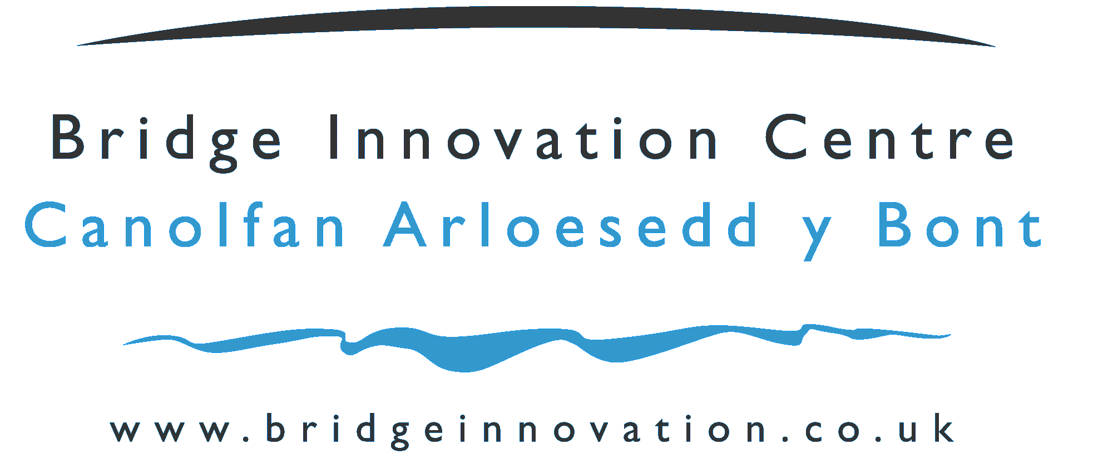 | 

Application for Associate Membership of the Bridge Innovation Centre/Pembrokeshire Science and Technology Park

Company Name

Date Application Submitted

Application for Associate Membership of the Bridge Innovation Centre

Thank you for the interest you have shown in applying for associate membership in the Bridge Innovation Centre.

The Bridge Innovation Centre has a twin objective – to provide an environment to enable new, young, innovative technology and knowledge based companies to thrive and expand – and to attract similar innovative high value satellite organisations from international blue chip companies. Both of these objectives aim to generate jobs of higher worth in the Pembrokeshire Economy. The Pembrokeshire Science and Technology Park facility is much more than a set of buildings, it represents the blueprint for an approach to innovation that incorporates state-of-the-art infrastructure, university expertise and business support on one campus.

“The Bridge Innovation Centre” on the Science and Technology Park will be a beacon for all that is good in business, innovation, science, technology, and knowledge in Pembrokeshire. The Bridge Innovation Centre will provide an environment that provides the relevant inputs into businesses to enable them to grow and make a positive contribution to the local economy. We will achieve this through our developing relationships with partners in business and higher education.

Associate Membership

For many businesses and companies, residency in the Bridge Innovation Centre is not a requirement. However, many businesses see the worth of association with the centre. A programme of Associate Membership has been developed particularly to allow businesses to enjoy some of the facilities that the Bridge Innovation Centre and Pembrokeshire Science and Technology Park have to offer. These include discounted hire of the meeting rooms, drop-in access to the atrium for informal meetings, use of the WIFI Internet access when visiting for the day, use of Video Conferencing facilities, access to university knowledge transfer, and invitations to the many events that take place in the centre. Membership is by application using this application form and discussion with the Pembrokeshire Science and Technology Park Team.

Selection Process

To progress your application, please complete the following form. We may ask for further information.

Please ensure the following topics are addressed within this application:

- Product / Service
- Present Business Status
- Composition of Management Team
- Any IPR held or being developed
- The markets your business works in

Your application will be quickly assessed and you will be notified of the outcome. You will then be asked to agree and sign an associate membership license.

Company Name:
Current Address:
Tel No: |  |  |  | Fax No:
e-mail:
Contact Name:
Position within Company:
Email:
Web Site:
Date Started Trading (SME):
No. of Employees
What is the structure of the Company Ownership? : e.g. holding company, Ltd Company ( include % of ownership), Sole Trader, Not yet formed but will be:
What is (are) the Standard Industry Classification Code(s) for your business?

Describe the nature of the business of the company:

Describe what innovation means to the business of the company:

Company Development to date : e.g. Provide an overview of the history of the company, how it developed e.g. from a University spin out, an entrepreneurial venture etc.

Please use the space below for any further comments you wish to make in support of your application for associate membership:

To be signed by a Director or Principal

Position |  | Date
Signature
return by e-mail will be interpreted as signed.

Please be assured that the information provided in connection with your application will be treated in the strictest confidence.

Please forward your completed application form to:

Rose Kennington
Team Leader
Bridge Innovation Centre
Pembrokeshire Science and Business Park
Pembroke Dock
Pembrokeshire
SA72 6UN

Tel: 01646 689302
Fax: 01646 689310
E-mail: rose.kennington@pembrokeshire.gov.uk

