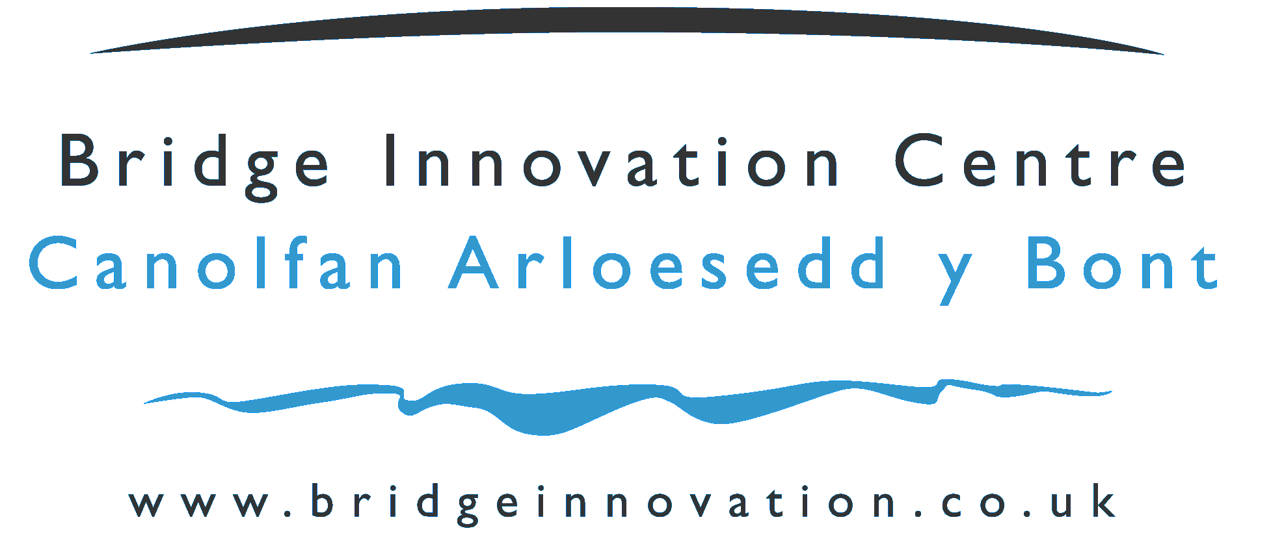 | 

Application for Dedicated Desk License within
the Pembrokeshire Science and Technology Park Facility

Company Name

Date Application Submitted

Application for a Dedicated Desk in the Pembrokeshire Science and Technology Park Facility

Thank you for the interest you have shown in applying for a hot desk in the Pembrokeshire Science and Technology Park Facility

The Bridge Innovation Centre has a twin objective – to provide an environment to enable new, young, innovative technology and knowledge based companies to thrive and expand – and to attract similar innovative high value satellite organisations from international blue chip companies. Both of these objectives aim to generate jobs of higher worth in the Pembrokeshire Economy. The Pembrokeshire Science and Technology Park facility is much more than a set of buildings, it represents the blueprint for an approach to innovation that incorporates state-of-the-art infrastructure, university expertise and business support on one campus.

“The Bridge Innovation Centre” on the Science and Technology Park will be a beacon for all that is good in business, innovation, science, technology, and knowledge in Pembrokeshire. The Bridge Innovation Centre will provide an environment that provides the relevant inputs into businesses to enable them to grow and make a positive contribution to the local economy. We will achieve this through our developing relationships with partners in business and higher education.

Dedicated Desk Membership

A programme of Dedicated Desk Membership has been developed particularly to allow early stage businesses to have a soft landing in the Science and Technology Park to build a relationship with the Science and Technology Park team and to assess if the facilities are suitable for growth aspirations. Dedicated Desk Members have access to many of the facilities and support functions of the Pembrokeshire Science and Technology Park facility such as use of a dedicated desk in the shared office, WIFI Internet access, use of the Science and Technology Park address, a direct dial in telephone number, use of Video Conferencing facilities, access to meeting rooms, access to university knowledge transfer, such members use the facility on a 24/7 access basis. Membership is by application using this application form and discussion with the Pembrokeshire Science and Technology Park Team.

Selection Process

To progress your application, please complete the following form. We may ask for further information.

Please ensure the following topics are addressed within this application:

- Product / Service
- Present Business Status
- Composition of Management Team
- Any IPR held or being developed
- Target markets

Your application will be quickly assessed and you will be notified of the outcome. You will then be asked to agree and sign a hot desk license.

Company Name
Current Address
Company Registration No. if Limited
Tel No. |  |  |  | Fax No.
Contact Name
Position within Company
Email
Web Site
Date Started Trading
No. of Employees |  |  |  |  | Turnover
What is the structure of the Company Ownership? : e.g. holding company, Ltd Company ( include % of ownership), Sole Trader, Not yet formed but will be:
What is (are) the Standard Industry Classification Code(s) for your business?

Describe the nature of the business of the company:

Describe what innovation means to the business of the company:

Company Development to date : e.g. Provide an overview of the history of the company, how it developed e.g. from a University spin out, an entrepreneurial venture etc.
Please describe the activity that you expect to carry out within the facility.

What are your expectations of your period in the facility?

Explain what will constitute a successful period of residency for your company within Pembrokeshire Science and Technology Park building.

Please use the space below for any further comments you wish to make in support of your application for residency/membership:

Declaration

To the best of my knowledge, the information given in this application form and attached business plan is correct. Completion of this application form does not constitute an offer of any space nor does it form part of any contract.

To be signed by a Director or Principal

Position |  | Date
Signature

Please be assured that the information provided in connection with your application will be treated in the strictest confidence.

Please forward your completed application form to:

Rose Kennington
Pembrokeshire Science and Business Park
Pembroke Dock
Pembrokeshire
SA72 6UN

Tel: 01646 689302
Fax: 01646 689310
E-mail: rose.kennington@pembrokeshire.gov.uk

