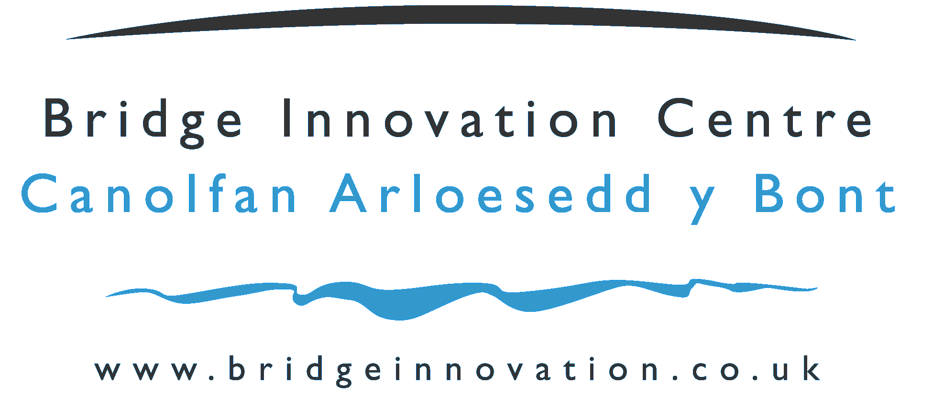 | 

Application for Growth Residency at Pembrokeshire Science and Technology Park

Company Name

Date Application Submitted

Application for Residency in the Pembrokeshire Science and Technology Park Facility

Thank you for the interest you have shown in occupying a growth unit at the Pembrokeshire Science and Technology Park Facility

The Pembrokeshire Science and Technology Park has a twin objective – to provide an environment to enable new, young, innovative technology and knowledge based companies to thrive and expand – and to attract high value satellite organisations from international blue chip companies. Both of these objectives aim to generate jobs of higher worth in the Pembrokeshire Economy. The Pembrokeshire Science and Technology Park facilities are much more than a set of buildings, they represents the blueprint for an approach to innovation that incorporates state-of-the-art infrastructure, university expertise and business support on one campus.

The Pembrokeshire Science and Technology Park is a beacon for all that is good in business, innovation, science, technology and knowledge in Pembrokeshire and aims to provide an environment that imparts positive inputs into businesses to make a contribution to the economy. We achieve this firstly through the Science and Technology Team Leader and then by relationships with partners in business and higher education.

Selection Process

To progress your application, please complete the following form. We may ask for further information.

Please ensure the following topics are addressed within this application:

- Product / Service
- Present Business Status
- Composition of Management Team
- Any IPR held or being developed
- Target markets

A due diligence and financial review will be undertaken by Pembrokeshire County Council (we may ask for more information for example Finances such as your last audited accounts and your financial forecast for the next 1-2 years). The final stage will be a review of the application by a Selection Committee comprising representatives of Pembrokeshire County Council Business Development team and the Pembrokeshire Science and Technology Team Leader, a representative from your company may be invited to meet the panel and discuss your application.

Company Name
Current Address
Company Registration No. if Limited
Tel No. |  |  |  | Fax No.
Contact Name
Position within Company
Email
Web Site
Date Started Trading
No. of Employees |  |  |  |  | Turnover
What is the structure of the Company Ownership? : e.g. holding company, Ltd Company ( include % of ownership), Sole Trader, Not yet formed but will be:
What is (are) the Standard Industry Classification Code(s) for your business?

Describe the nature of the business of the company:

Describe what innovation means to the business of the company:

Company Development to date : e.g. Provide an overview of the history of the company, how it developed e.g. from a University spin out, an entrepreneurial venture etc.

Please describe the activity that will be carried out within the facility. (Particularly if your company is intending to move into a growth unit please give details of any processes involving inflammable, noxious or dangerous materials or processes).

Please state preferred size of unit:

Growth Unit 1500 sq ft |  | Growth Unit 3000 sq ft

How does your business expect to benefit from being located at the Pembrokeshire Science and Technology Park?

Explain what will constitute a successful period of residency for your business within Pembrokeshire Science and Technology Park building. (i.e. how will your business have grown and developed over a 3 to 5 year period?)

Please use the space below to add any further comments that you wish to make in support of your application for residency in the Pembrokeshire Science and Technology Park:

Declaration

To the best of my knowledge, the information given in this application form and any attached documentation is correct. Completion of this application form does not constitute an offer of any space nor does it form part of any contract or lease.

To be signed by a Director or Principal

Position |  | Date
Signature

Please be assured that the information provided in connection with your application will be treated in the strictest confidence.

Please forward your completed application form, together with your Business Plan, and requested finances (if appropriate) to:

Rose Kennington
Team Leader
Pembrokeshire Science and Business Park
Pembroke Dock
Pembrokeshire
SA72 6UN

Tel: 01646 689302
Fax: 01646 689310
E-mail: rose.kennington@pembrokeshire.gov.uk

